Deb Stratas announces the release of her second historical novel,
Diana, A Spencer in Turmoil

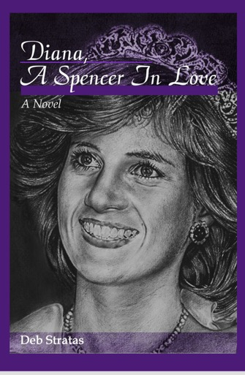
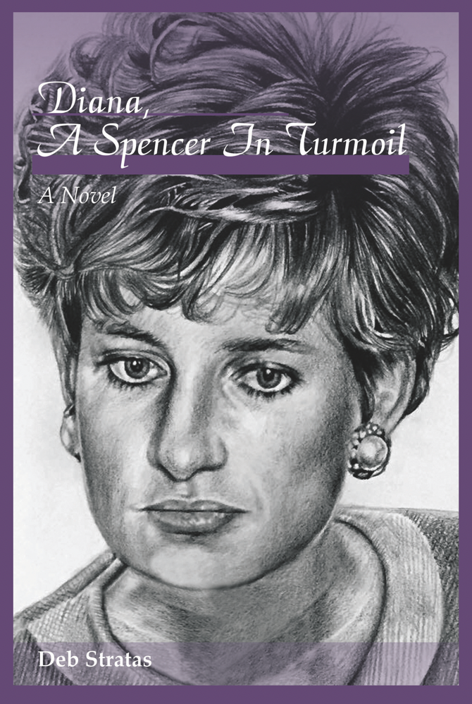
A Royal Princess is trapped in a loveless marriage. A relentless paparazzi stalk her every move. Explosive secrets about bulimia, suicide attempts, a cheating husband and a disintegrating fairy tale are about to be revealed to a stunned world. Can Princess Diana find a way to escape her gilded cage?

Diana, A Spencer in Turmoil explores the extraordinary events of 1992 as they unfolded to that fateful moment when the British Prime Minister announced: “It is announced from Buckingham Palace that, with regret, the Prince and Princess of Wales have decided to separate.”

My first novel, Diana, A Spencer in Love was published in April 2017. It told the story of the Princess’s first extraordinary year of royal life as she met and married the Prince of her dreams. Or did she?

The third book in the series – Diana, A Spencer Forever, concludes the tale of the Princess of Wales in her final year of life - coming soon!

Follow Deb at @aboutdianabooks. and princessdianabooks. Find out more at princessdianabooks.com. All books available at amazon.com.

Deb Stratas is a writer based in Toronto, Canada. She’s a proud royalist with a lifelong passion for the British monarchy. An avid Diana-watcher for over 30 years, Deb was thrilled to cheer on the royal wedding of Prince William to Kate Middleton on the streets of London in 2011. She was also honoured to attend a Royal Garden Party at Buckingham Palace in 2015. She loves her two amazing adult children, their spouses and grand-daughter Eva.
Author Questions and Answers
Why write novels about Princess Diana?
I wrote two historical novels about Princess Diana’s royal life because I could never find a biography that went beyond facts and figures. I’ve read at least 50 books about her life but always felt her voice was missing – what was she thinking and feeling? How was she coping with the enormous changes in her life? How did she manage life in a “gilded cage?’ In essence, I wrote the book about Diana that I always wanted to read, but could never find. And I wanted to feature Diana’s Spencer heritage.

Are these books biased towards Diana’s views on her royal life?
One of the frustrations I’ve found with Princess Diana biographies is that authors seemed to be either Pro-Charles or Pro-Diana; and therefore mainly focused on supporting their own positions. In my research, I truly came to believe that both Charles and Diana loved each other when they married, and I wanted to paint a balanced picture of their life together as the fairytale crumbled. Yes, my books are written in Diana’s voice, but I was committed to look at the positive intent of all parties.

How historically accurate are Diana, A Spencer in Love and Diana, A Spencer in Turmoil?
To honor such a well-known and loved icon as Princess Diana, meticulous research is critical. Many of the events depicted in the books are based on real people, places and events. I hope I’ve represented them as factually as possible while enhancing the story with new scenarios, perspectives and dialogue. There are sometimes conflicting views of the same events – in those cases I’ve chosen (or created!) the versions that I believe best fit the characters as they were at that time – in the 1980’s and early ‘90’s– without the benefit of hindsight or editorial rewrites.

Can a Canadian write a British novel?
Yes! As a lifelong British monarchist, I have researched and studied the royal family and English history for over thirty years. I’ve visited the UK half a dozen times, and am a stickler for getting it right and showing respect for the monarchy and everyone associated with the house of Windsor. I chose to incorporate British language, customs, culture and even slang to make the novel as realistic as possible. And don’t forget, Canada is a loyal part of the British commonwealth, so my British heritage is the real deal.

What’s new for loyal Princess Diana followers?
True Diana fans won’t be disappointed with this rich accounts of her royal life. They’ll recognize familiar events and milestones. They’ll be introduced to new perspectives, even more rich detail about royal happenings, & royal residences, and most importantly – all told in the imagined voice of Diana – the incredible Princess of Wales. For anyone new to Diana’s life, the Diana Spencer trilogy will give a fresh picture of the Princess, and a peek inside “a day in the life” of the most famous royal of all time.

What’s next?
Diana, A Spencer Forever tells the story of the final year in Diana’s too-short life. Coming early January 2019!

